Corporate Governance

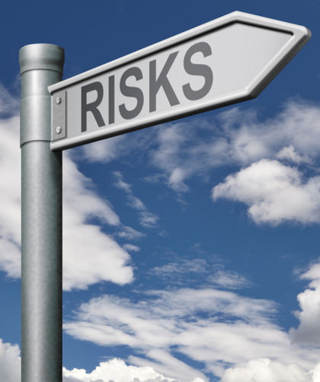
Systems to Manage your Risks
- Is there a risk that your business could fail?
- How good are your governance systems and processes?
- Do you have an effective risk management strategy?
- Do the people you have engaged to work in your business have the required skills and competence? Are they sufficiently motivated and committed?
- Do you need to change the culture in your business?
If any of the questions above raise any concerns for you, please contact us.
We provide comprehensive advice on:
- Governance structures
- Governance systems
- Governance processes
- Board evaluations
- In-house training, coaching and mentoring

Add Value to Your Business
Get the right processes in place so that compliance work does not damage your core commercial activity but adds value to your business making best use of its people and money.
Our work includes:
- Legal and financial compliance advice — helping you meet international reporting standards.
- Board development work— to ensure key obligations are understood and met.
- Risk management — to develop and deliver risk management strategies across the whole business.
- Corporate Social Responsibility – helping you take responsibility for the environmental and social welfare impact of your business.
- Advice in other industry specific areas of law such as Bribery and Corruption, Data Protection, Health and Safety, product liability, competition law especially where boards and individual directors may have potential personal liability.

Contact Us
For information on how we can help you, please contact:
David Buckle – Managing Partner +44 (0) 1732 228805 E: david@dmblaw.co.uk

